

SIMATS ENGINEERING

Saveetha Institute of Medical and Technical Sciences

Building a Unified Data Warehouse and Data-Mining Pipeline for an
E-Commerce Platform: Customer Analytics and Churn Forecasting

Assignment Report
Submitted in partial fulfilment of the requirements for the course

Course Code — CSA1613, Data Warehousing and Data Mining
towards the award of the degree of
BACHELOR OF ENGINEERING
in Artificial Intelligence and Machine Learning

Submitted by

UPPU SYE KUMAR — 192325121
VELAMARTHI DIMPU SPANDANA — 192311065
VEMULAPATI DHARANI — 192311219

Under the Supervision of
Dr. K.V. Kanimozhi

Chennai — 602105
Date of Submission: August 2026

Table of Contents
S.No | Content | Page No
1 | Understanding the Problem and Business Requirements | 3
2 | Core Concepts of Data Warehousing | 4
3 | Source Systems, Data Integration and the ETL Pipeline | 7
4 | Data Preprocessing — Ideas and Methods | 10
5 | Warehouse Schema Design — Star Schema | 11
6 | OLAP and Multidimensional Analysis | 13
7 | Foundations of Data Mining and Classification Techniques | 15
8 | Evaluating Models, Cross-Validation and Related Ideas | 20
9 | Comparing and Selecting Models, Business Interpretation | 22
10 | Implementation, Visualisation and Documentation in KNIME / Weka | 23

1. Understanding the Problem and Business Requirements
Business context. A typical online retailer runs several separate operational systems side by side — a customer-relationship platform, an order-processing system, a product catalogue, a payment gateway, a logistics/delivery tracker, and a clickstream logger that records website activity. Because these systems were never designed to talk to each other, management has no single, consolidated picture of how customers actually shop, cannot easily tell which products or geographies are generating the most revenue, and has no early signal that would flag a customer who is about to stop buying (churn). This assignment sets out to design and implement a combined Data Warehousing and Data Mining solution that tackles both gaps together.

1.1 Business Requirements
- Build a single, historically consistent view of customers, orders, products, payments, deliveries and web behaviour that reporting and decision-support tools can rely on.
- Enable fast multidimensional (OLAP) exploration of sales across time, product, customer, region and payment/delivery channel.
- Surface the best-selling products, the most valuable customer groups, seasonal demand swings, and differences in regional performance.
- Flag customers who are likely to churn before they actually leave, so retention teams can act early and cost-effectively.
- Keep the solution scalable and reproducible while respecting customer privacy and fairness.

1.2 Data Sources and Key Entities Identified
Source System | Key Entities / Attributes | Refresh Rate | Format
Customer database (CRM) | Customer_Id, Name, Gender, DOB, City, Signup_Date, Contact | Daily (CDC) | Relational (MySQL/PostgreSQL)
Order management system | Order_Id, Customer_Id, Product_Id, Qty, Order_Date, Status | Real-time / hourly | Relational + REST API
Product catalogue | Product_Id, Name, Category, Sub-category, Brand, Price, Cost | Weekly | Relational / CSV export
Payment gateway | Payment_Id, Order_Id, Mode, Status, Amount, Timestamp | Real-time | JSON logs / API
Delivery / logistics | Delivery_Id, Order_Id, Courier, Dispatch/Delivery Date, Status | Daily | CSV / API
Website interaction log | Session_Id, Customer_Id, Page_Views, Cart_Adds, Time_on_Site | Streaming | Clickstream logs (JSON)

1.3 Scope and Deliverables
The work is split into three connected stages. First, the six operational systems listed above are combined into a dimensional warehouse through a documented ETL process (Section 3). Second, the resulting warehouse is explored using OLAP techniques to pull out business insight (Section 6). Third, a data-mining stage trains and compares several classification models to forecast customer churn and proposes retention actions based on the results (Sections 7–9). Section 2, which follows, first establishes the theory that underpins the design choices made in every later stage.

2. Core Concepts of Data Warehousing
Before the ETL pipeline and schema can be designed, it helps to fix the theoretical vocabulary that every later design choice in this report will refer back to.

2.1 What Does 'Data Warehouse' Actually Mean?
W.H. Inmon, often credited as the founder of the data-warehousing discipline, described a Data Warehouse as a subject-oriented, integrated, time-variant and non-volatile collection of data that exists to support management's decision-making. Each of these four properties is expanded below and contrasted with how an everyday transactional (OLTP) database behaves.
Property | Meaning | Contrast with an OLTP database
Subject-oriented | Organised around core business subjects (customer, product, sales) rather than individual applications | OLTP is organised around business processes/functions (order entry, billing)
Integrated | Data pulled from many different sources is reconciled into one consistent form (naming, units, encoding) | Each OLTP system keeps its own local, often inconsistent, conventions
Time-variant | Every record carries a point or period in time, so history is retained | OLTP keeps only the current state — older values are overwritten
Non-volatile | Once loaded, data is normally only appended, not updated or deleted | OLTP data is continuously inserted, updated and deleted

2.2 OLTP versus OLAP
The six operational sources described in Section 1.2 are OLTP systems. The warehouse and the analytics that sit on top of it form the OLAP side. Running heavy analytical queries directly against a system like the order database — instead of against the warehouse — is exactly the situation this design is meant to prevent.
Aspect | OLTP (Online Transaction Processing) | OLAP (Online Analytical Processing)
Purpose | Keeps the business running day to day (record an order, update stock) | Analyses the business — trends, comparisons, forecasts
Data model | Highly normalised (3NF) to avoid update anomalies | Denormalised, dimensional (star/snowflake) for read speed
Typical operation | Short, frequent read/write transactions | Complex, long-running read-only aggregate queries
Data currency | Current data only | Historical, time-variant data
Users | Clerks, cashiers, front-line applications | Analysts, managers, data-mining algorithms
Example query | "Insert this new order" | "What was Q4 revenue by region and category, year over year?"

2.3 Layered Architecture of a Data Warehouse
A data warehouse is usually built as a stack of three tiers, and all three are implemented in this design:
- Bottom tier (source / staging layer): the six OLTP sources together with a staging area that temporarily holds raw extracts before they are cleaned — see Section 3.
- Middle tier (OLAP server): the engine that exposes the data multidimensionally so it can be sliced and diced quickly — discussed in Section 6 under ROLAP/MOLAP/HOLAP.
- Top tier (presentation layer): the reporting tools, dashboards, and the data-mining layer that all consume the resulting cube — covered in Sections 7–9.

2.4 Dimensional Modelling: Facts, Dimensions and Measures
Fact table: holds the quantitative, numeric measurements of a business process (for example Total_Sales_Amount) together with foreign keys pointing to the dimensions that give the number context. Facts can be additive (summable across every dimension), semi-additive (summable across some dimensions only — an account balance, for instance, cannot be summed across time), or non-additive (ratios and percentages).
Dimension table: carries the descriptive, textual context — who, what, where, when — that lets business users filter and group the facts. Dimension tables tend to be wide and shallow, either fully denormalised (a Star Schema) or partly normalised into sub-dimensions (a Snowflake Schema).
Measure: a numeric column inside the fact table that an aggregate function (SUM, AVG, COUNT, MIN, MAX) is applied to — for example SUM(Total_Sales_Amount).
Grain: the level of detail a single fact-table row represents (here, one row equals one product line item within one order). Fixing the grain correctly is arguably the single most important dimensional-modelling decision: too coarse a grain sacrifices analytical flexibility, while too fine a grain drives up storage and processing cost.

2.4.1 Types of Schema
Schema | Structure | Advantage | Disadvantage
Star Schema | One central fact table joined directly to fully denormalised dimension tables | Simple, fast joins; easy for business users and BI tools to query | Some redundancy inside dimension tables (e.g. Category repeated per product)
Snowflake Schema | Dimension tables are further normalised into sub-dimension tables (e.g. Dim_Product → Dim_Category) | Saves storage, enforces referential integrity within dimensions | More joins → slower queries, more complex for end users
Fact Constellation (Galaxy Schema) | Several fact tables share one or more conformed dimensions | Models multiple related business processes together (e.g. Sales plus Web Interaction) | More complex to design and maintain; risk of dimension-conformance errors

Design choice justification: this project settles on a Star Schema (built out in Section 5) because, at this data volume, the gains in query simplicity for business analysts and in OLAP-tool performance outweigh the storage saved by a snowflake. The design can later evolve into a Fact Constellation simply by adding a Fact_Web_Interaction table against the same conformed Dim_Time / Dim_Customer / Dim_Location dimensions.

2.4.2 Categories of Fact Table
Transaction fact table: one row per discrete business event — used here, with one row per order line item.
Periodic snapshot fact table: one row per fixed time interval (a daily inventory snapshot, for instance), useful for balances or levels that have no natural transaction.
Accumulating snapshot fact table: one row per process instance, updated in place as the process moves forward — for example one row per order that is updated as it progresses from Ordered to Paid to Shipped to Delivered.

2.4.3 Categories of Dimension
Conformed dimension: a dimension such as Dim_Time or Dim_Location that is shared identically across several fact tables so results can be combined or compared — essential for the Fact Constellation extension mentioned earlier.
Degenerate dimension: a dimension attribute that has no supporting table of its own and is stored directly inside the fact table, such as Order_Id within Fact_Sales.
Junk dimension: a single dimension that bundles together several small, low-cardinality flags (Is_Gift_Wrapped, Is_First_Order) that would otherwise clutter the fact table.
Role-playing dimension: one physical dimension used more than once within the same fact table, each time with a different meaning — Dim_Time, for example, playing the role of both Order_Date and Delivery_Date.

2.4.4 Slowly Changing Dimensions (SCD)
Dimension attributes do not always stay fixed — a customer's segment or city, for example, can change over time. How the warehouse copes with such a change is what the Slowly Changing Dimension strategy governs:
SCD Type | Behaviour on Change | Historical Accuracy | Used in this design for
Type 0 | The attribute is never updated once it has been loaded | N/A — the original value is frozen permanently | Signup_Date (a value that should never change)
Type 1 | The old value is simply overwritten with the new one | History is lost | Correcting a data-entry error (e.g. a misspelled name)
Type 2 | A new row is inserted with a fresh surrogate key and a validity date range; the old row is kept but marked expired | Full history is preserved | Dim_Customer.Segment / Churn_Flag (Section 5)
Type 3 | A new column is added to hold the previous value alongside the current one | Limited history (only one prior value) | Not used here — included for completeness

3. Source Systems, Data Integration and the ETL Pipeline
ETL concept. ETL — Extract, Transform, Load — is the process that moves data out of the heterogeneous OLTP sources and into the dimensional warehouse defined in Section 2. A related pattern, ELT (Extract, Load, Transform), loads the raw data first and then transforms it using the compute available inside the target platform — common with modern cloud warehouses such as BigQuery or Snowflake. This project follows the classic ETL route instead, because transformation logic such as SCD Type 2 handling and RFM feature engineering is easier to version-control and unit-test outside the warehouse itself.
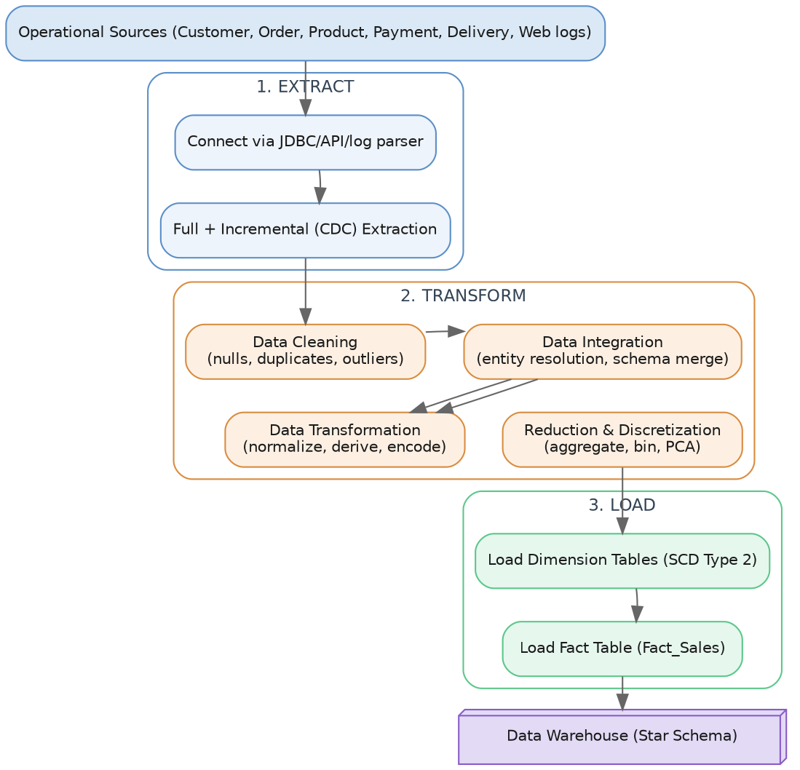
Fig. 1 — Overall ETL flow: Extract, then Transform (Clean / Integrate / Transform / Reduce), then Load

3.1 Extract
Extraction pulls data out of each source system without changing it. Two strategies are used:
Full extraction: reads an entire source table on every run. Simple, but expensive — reserved for the initial bootstrap of the warehouse only.
Incremental extraction (Change Data Capture, CDC): reads only the rows that changed since the previous run, identified through a Last_Modified timestamp, a database transaction log, or a trigger-based change table. This is the method used for every run after the first, for both Orders and Web logs.
- Connect to each of the six sources with the appropriate connector — JDBC for the relational databases, a REST client for the payment/API sources, and a log parser for the clickstream JSON.
- Land the raw extracts, unmodified, in a staging area (flat files or a staging schema) so the original source-of-truth remains reproducible and every run can be repeated if needed.

3.2 Transform

3.2.1 Cleaning the Data
Cleaning removes noise, missing values, duplicates and inconsistencies — skipping this step is the single biggest cause of poor accuracy later in the mining models.
Handling missing values: options include (a) deleting the record, appropriate only when the missing field is the class label itself or the loss is negligible; (b) filling it in manually, which does not scale; (c) substituting a constant such as "Unknown"; (d) filling with the attribute's mean/median for numeric fields or mode for categorical ones; and (e) predicting the most probable value with regression, a decision tree, or k-Nearest-Neighbour imputation. This project uses mode/median imputation for Age, City and Delivery_Date, and drops only the Order_Id records that cannot be recovered.
Handling noisy data and outliers: (a) binning — sort values into equal-width or equal-frequency bins and smooth using the bin mean, median or boundary; (b) regression — fit a function and replace values with the predicted ones; (c) clustering — group similar values together and treat anything falling outside a cluster as an outlier; (d) statistical thresholding — flag anything beyond a Z-score or IQR bound as an outlier.
Z-score: z = (x − μ) / σ — an observation with |z| > 3 is flagged as an outlier
IQR = Q3 − Q1
lower bound = Q1 − 1.5×IQR, upper bound = Q3 + 1.5×IQR

Duplicate detection: exact matching on identifiers such as Order_Id, combined with fuzzy/approximate matching (edit distance or phonetic matching on Name plus Email) to catch near-duplicate customer records created by typos entered across different systems.

3.2.2 Integrating the Data
Concept. Data integration merges data from multiple sources into one coherent store. Two classic problems have to be resolved along the way:
Entity identification problem: the same real customer may be identified differently in different systems — Customer_Id in the CRM versus an email address in the payment gateway, for instance. This is resolved here with a master crosswalk key-mapping table and a set of record-linkage rules.
Redundancy and correlation analysis: once the sources are merged, some attributes may turn out to be redundant (derivable from others) or highly correlated, which inflates dimensionality without adding real information. This is detected using the χ² (chi-square) test for nominal attributes and the Pearson correlation coefficient for numeric ones.
Pearson r(A,B) = Σ(aᵢ − Ā)(bᵢ − B̄) / [(n − 1) σₐ σᵦ] (ranges from −1 to +1)

Schema and semantic conflicts also need reconciling — naming differences such as Cust_ID versus customerId, unit differences such as INR versus USD or kg versus g, and structural differences such as one system storing a single Full_Name field while another splits it into First and Last.

3.2.3 Transforming the Data
Transformation reshapes the cleaned, integrated data into the form the warehouse and the mining algorithms actually need.
Smoothing: removing noise, as described under binning/regression above.
Aggregation: summarising records — for example rolling up individual clickstream events into a daily session count — which also doubles as a data-reduction technique (Section 3.2.4).
Generalisation: replacing detailed, low-level values with a higher-level concept using a concept hierarchy, such as City → State → Region → Country.
Normalisation: rescaling numeric attributes onto a common range so that no single attribute dominates a distance-based algorithm — essential for SVM, k-NN and clustering.
Min-Max: v' = (v − min_A)/(max_A − min_A) × (new_max − new_min) + new_min
Z-score: v' = (v − μ_A) / σ_A
Decimal scaling: v' = v / 10^j, where j is the smallest integer such that max|v'| < 1

Attribute/feature construction: deriving new, more predictive attributes from existing ones, e.g. Total_Sales_Amount = Quantity × Unit_Price − Discount; Delivery_Days = Delivery_Date − Order_Date; and Recency/Frequency/Monetary (RFM) features built for the churn model.
Encoding categorical attributes: One-Hot Encoding (a binary column per category — safe for nominal fields with no order, though it raises dimensionality) and Label Encoding (each category mapped to an integer — compact, but it implies an ordinal relationship that is only appropriate for genuinely ordinal attributes).

3.2.4 Reducing and Discretising the Data
Concept. Data reduction produces a smaller representation of the dataset that still preserves its analytical value, cutting mining runtime while keeping accuracy intact.
Dimensionality reduction: Principal Component Analysis (PCA) turns possibly correlated features into a smaller set of uncorrelated "principal components" ranked by the variance they explain, keeping only the components that capture most of that variance. Attribute subset selection — stepwise forward selection or correlation filtering, for example — is a simpler alternative that keeps the original, interpretable features.
Numerosity reduction: replacing the raw data with a smaller model or sample, either parametric (regression models) or non-parametric (histograms, clustering, sampling). This is used here to compress raw clickstream events into session-level summaries before they reach the fact table.
Data compression: lossless schemes (run-length or entropy encoding) or lossy schemes (wavelet transforms) applied to shrink storage.
Discretisation: converting a continuous attribute into a small number of interval labels, which both reduces the data and can improve certain algorithms — Naive Bayes in particular. Methods include equal-width binning, equal-frequency binning, entropy-based (supervised) discretisation, and clustering-based discretisation. This project discretises Age into Age_Group and Recency into Recency_Band using business-defined, equal-frequency bins.
Concept hierarchy generation: arranging discretised values into a hierarchy — Day → Month → Quarter → Year for Dim_Time — which directly powers the roll-up/drill-down OLAP operations described in Section 6.

3.3 Load
- Load the dimension tables first, applying Slowly-Changing-Dimension Type 2 to Dim_Customer (Section 2.4.4) so that segment/address history is preserved.
- Load the fact table(s) last, resolving their foreign keys against the dimensions that are already in place (a referential-integrity check).

4. Data Preprocessing — Ideas and Methods, Summarised
Why preprocessing matters: real-world data is typically incomplete (attribute values missing), noisy (containing errors or outliers) and inconsistent (containing discrepancies between sources) — the three classic data-quality problems described throughout the data-mining literature. Section 3.2 explained the underlying techniques in detail; the table below simply maps each technique to the specific problem it solves within this pipeline, which is the justification expected in the reflection.
Technique | Applied To | Method | Justification
Missing-value handling | Age, City, Delivery_Date | Mode/median imputation, business-rule defaults | Preserves record volume without introducing bias
Duplicate removal | Customer, order records | Fuzzy match on name + email; exact match on Order_Id | Prevents double-counting of revenue/customers
Outlier treatment | Order_Amount, Delivery_Days | IQR capping (1.5×IQR) | Retains extreme-but-valid high-value orders
Normalisation | Numeric mining features | Min-Max scaling to [0,1] | Required for distance-based/SVM models (Section 7.4)
Encoding | Categorical attributes | One-hot (nominal), Label (ordinal) | Makes categorical data usable by all three classifiers
Discretisation | Age, Recency, Tenure | Equal-frequency / business-defined bins | Improves Naive Bayes performance and interpretability
Dimensionality reduction | Churn feature set | Correlation filter + PCA (optional) | Reduces overfitting risk, speeds up SVM training

4.1 Why the Data-Quality-to-Model-Quality Chain Matters
This stage carries a heavy weight in the rubric for a reason: every OLAP aggregate downstream and every classification model's accuracy is only as trustworthy as the data that feeds it. This is the idea behind the well-known phrase "Garbage In, Garbage Out" (GIGO) — no algorithm, no matter how sophisticated, can produce dependable churn predictions from uncleaned, inconsistent or biased input.

5. Warehouse Schema Design — Star Schema
Design choice: building on the schema theory covered in Section 2.4.1, a Star Schema (rather than a Snowflake) is chosen as the primary model, because query performance and ease of use for business analysts matter more at this scale than the storage saved by normalisation. Dim_Product could optionally be snowflaked into Category/Sub-category later if the catalogue grows very large.
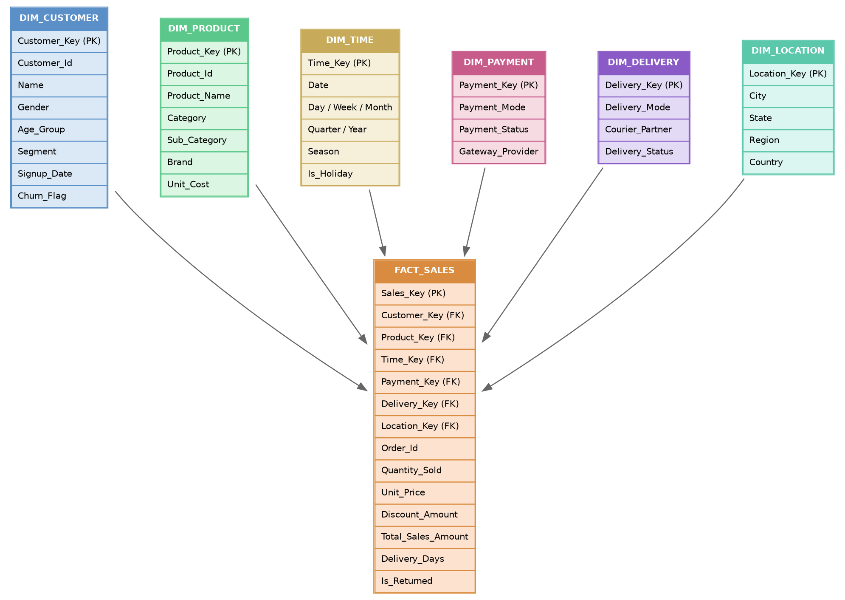
Fig. 2 — Star schema with FACT_SALES at the centre, surrounded by six conformed dimensions

5.1 Fact Table — FACT_SALES
Grain: one row per product line item, per order (see the grain concept in Section 2.4). Type: a transaction fact table (Section 2.4.2) with three additive measures — Quantity_Sold, Total_Sales_Amount and Discount_Amount, all summable across every dimension — plus one semi-additive measure, Delivery_Days, which should be averaged rather than summed across time.

5.2 Dimension Tables
Dimension | Purpose | Notable Attributes | SCD Type
Dim_Customer | Who bought | Segment, Age_Group, Signup_Date, Churn_Flag | Type 2
Dim_Product | What was bought | Category, Sub_Category, Brand, Unit_Cost | Type 1
Dim_Time | When | Day, Week, Month, Quarter, Year, Season, Is_Holiday | Type 0
Dim_Payment | How paid | Payment_Mode, Payment_Status, Gateway_Provider | Type 1
Dim_Delivery | How fulfilled | Delivery_Mode, Courier_Partner, Delivery_Status | Type 1
Dim_Location | Where | City, State, Region, Country | Type 2

5.3 Why This Design Supports the Required Analysis
- Every business question raised in the assignment — best-selling products, customer segments, seasonality, regional performance, high-value customers — maps directly onto a single dimension plus the additive measures in Fact_Sales, so each can be answered with one GROUP BY / OLAP cube query. This is the practical payoff of the dimensional-modelling theory covered in Section 2.4.
- Conformed dimensions such as Dim_Time and Dim_Location (Section 2.4.3) can later be reused by a second fact table (Fact_Web_Interaction) if clickstream analysis is added, without redesigning anything — turning the star into a fact constellation.

6. OLAP and Multidimensional Analysis

6.1 The OLAP Cube
Concept. An OLAP cube (also called a "data cube") is a multidimensional array of values, usually built from a star schema, where each axis represents a dimension (Time, Product, Location, Customer) and each cell holds an aggregated measure such as SUM(Total_Sales_Amount). It is drawn as a three-dimensional cube purely for intuition — the same idea generalises to any number of dimensions, sometimes called a "hypercube".

6.2 OLAP Server Architectures
Architecture | How Data Is Stored | Query Speed | Scalability | Typical Use
MOLAP (Multidimensional OLAP) | Pre-aggregated in a proprietary multidimensional array structure | Very fast (pre-computed) | Limited by cube storage — struggles as dimensionality grows ("sparsity") | Small/medium cubes needing sub-second dashboards
ROLAP (Relational OLAP) | Stored in standard relational tables; aggregates computed on the fly with SQL | Slower (computed at query time) | Scales with the relational engine — handles very large volumes | Large warehouses (this assignment's Fact_Sales)
HOLAP (Hybrid OLAP) | Detail data kept in relational tables, summary data pre-aggregated in a MOLAP cube | Balanced | Balanced | Warehouses needing both drill-to-detail and fast summaries

6.3 The Five Core OLAP Operations
An OLAP cube (or equivalent SQL GROUP BY / CUBE / ROLLUP queries) is built on Fact_Sales using the dimensions Time, Product, Customer and Location, with Total_Sales_Amount as the measure. The five operations below are demonstrated and interpreted against that cube.
Operation | Definition | Example on This Cube | Business Insight Produced
Roll-up | Aggregating from a lower to a higher level of a concept hierarchy (Section 3.2.3), reducing detail | Daily sales → Monthly → Quarterly sales | Reveals seasonal sales patterns and growth trend
Drill-down | The reverse of roll-up — moving from a higher to a lower level of detail | Region sales → State → City sales | Pinpoints which city drives a region's performance
Slice | Fixing one dimension to a single value and viewing the remaining dimensions as a sub-cube | Sales for Time = "Q4 2025" across all products | Isolates a single period for festive-season analysis
Dice | Selecting a smaller sub-cube by fixing values or ranges on two or more dimensions | Sales where Region = South AND Category = Electronics | Focused view for a regional-category campaign
Pivot (rotate) | Rotating the cube's axes to view the data from a different cross-tabular angle | Rows = Product Category, Columns = Payment_Mode | Shows which categories favour COD versus online payment

6.4 Analytical Questions the Cube Should Answer
- Best-selling products — roll up Total_Sales_Amount by Dim_Product.Category, ranked in descending order.
- Customer segments — dice by Dim_Customer.Segment × Dim_Time.Quarter and compare average order value.
- Seasonal sales patterns — roll up by Dim_Time.Season / Month and plot the resulting trend line.
- Regional performance — drill down through Dim_Location.Region → State → City on Total_Sales_Amount.
- High-value customers — slice on the top decile of Total_Sales_Amount per Customer_Key (the "Monetary" view of RFM, Section 7.1).

7. Foundations of Data Mining and Classification Techniques

7.1 What Is Data Mining? The KDD Process
Data mining is the process of digging out interesting, non-obvious, previously unknown and genuinely useful patterns from large volumes of data. It forms one stage inside the broader Knowledge Discovery in Databases (KDD) process, which runs through the following stages:
- Data Cleaning — removing noise and inconsistent data (Section 3.2.1).
- Data Integration — combining multiple sources (Section 3.2.2).
- Data Selection — pulling out the data relevant to the analysis task from the warehouse.
- Data Transformation — consolidating data into a form suitable for mining, e.g. aggregation (Section 3.2.3).
- Data Mining — applying intelligent methods, here classification algorithms, to extract patterns.
- Pattern Evaluation — identifying which patterns genuinely represent useful knowledge, using interestingness measures (Section 8).
- Knowledge Presentation — visualising and presenting the mined knowledge to the business user (Sections 9–10).
Mapped onto this assignment: Sections 3–4 carry out steps 1–4 (the ETL/preprocessing pipeline); this section (7) carries out step 5; Section 8 carries out step 6; and Sections 9–10 carry out step 7.

7.2 Classification as a Form of Supervised Learning
Classification is a supervised-learning task: a classifier is trained on historical records whose correct output class is already known (here, Churn_Flag = Churned or Active), so that it can then predict the class of new, unseen records. This is different from unsupervised learning — clustering customers into segments with no predefined labels, for example — which the assignment does not require directly but which would naturally extend the "customer segments" question raised in Section 1.
Target: Churn_Flag (binary: Churned / Active), defined as no purchase in the last 90 days.
Candidate features (drawn from the warehouse): Recency (days since the last order), Frequency (orders placed in the last 12 months) and Monetary (sum of Total_Sales_Amount) — together known as RFM analysis, a well-established customer-value feature-engineering technique — plus Average_Order_Value, Tenure_Days, the number of complaints/returns, Preferred_Category, Preferred_Payment_Mode, a delivery-satisfaction proxy (average Delivery_Days), and web engagement measures (average session time, cart-abandonment rate).
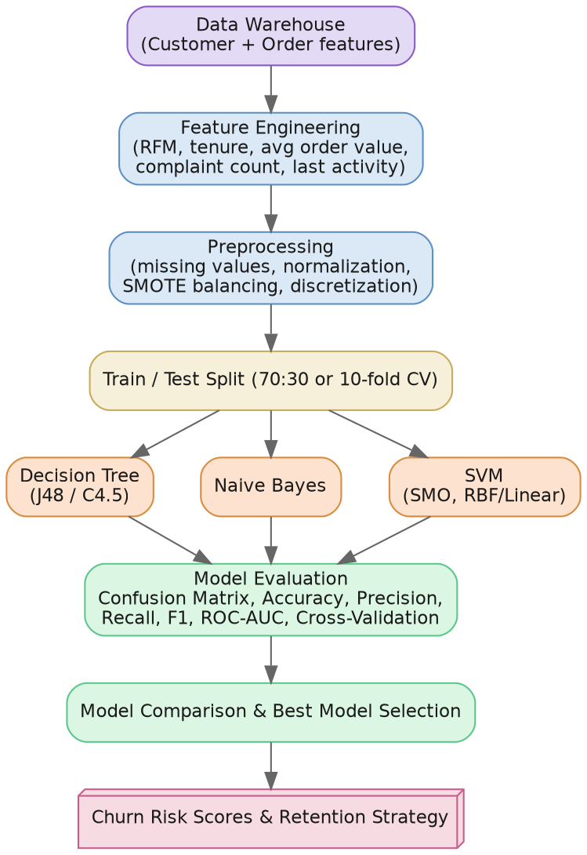
Fig. 3 — Data-mining workflow, from warehouse features through to churn-risk scores

7.3 Decision Tree Classifier
Concept. A decision tree repeatedly splits the training data into purer and purer subsets, at each step choosing the attribute test that best separates the classes. The result is a tree of if-then rules that a human — a retention agent, say — can read directly.

7.3.1 Splitting Criteria
At every node, the algorithm chooses the split that maximises class purity in the resulting child nodes. Three measures are commonly used:
Entropy (ID3/C4.5): Info(D) = −Σ pᵢ log₂(pᵢ), summed over i = 1..m classes
Information Gain: Gain(A) = Info(D) − Info_A(D)
Gain Ratio (C4.5): GainRatio(A) = Gain(A) / SplitInfo(A)
Gini Index (CART): Gini(D) = 1 − Σ pᵢ²

Here pᵢ is the proportion of records in D that belong to class i. A split that leaves lower entropy or Gini in the children (equivalently, a higher Information Gain) is preferred, because it produces purer child nodes. C4.5 introduced Gain Ratio specifically to correct ID3's bias toward attributes with many distinct values, such as Order_Id, which raw Information Gain tends to over-reward.

7.3.2 Algorithm Variants
Algorithm | Splitting Criterion | Handles | Notes
ID3 | Information Gain | Categorical attributes only | The original algorithm; biased toward high-cardinality attributes
C4.5 (→ Weka's J48) | Gain Ratio | Categorical and continuous attributes; missing values | Adds post-pruning to reduce overfitting — recommended for this assignment
CART | Gini Index | Categorical and continuous; binary splits only | Can also build regression trees

7.3.3 Overfitting and Pruning
A tree grown all the way to full depth can memorise the training data — including its noise — which hurts accuracy on new data. This is overfitting, discussed further in Section 8.5. Two families of pruning counteract it:
- Pre-pruning (early stopping): stopping tree growth early using a threshold — a minimum number of instances per leaf, a maximum depth, or a minimum information gain.
- Post-pruning: growing the full tree first and then removing branches that do not improve accuracy on a validation set (C4.5's error-based / cost-complexity pruning, for example). This is generally preferred because the decision is made only after the whole tree has been seen.

7.4 Naive Bayes Classifier
Concept. Naive Bayes is a probabilistic classifier built on Bayes' Theorem, with the simplifying ("naive") assumption of class-conditional independence — it treats the value of one feature, say Preferred_Category, as carrying no information about another feature, say Payment_Mode, once the class is already known. Real data rarely satisfies this assumption exactly, yet the classifier remains surprisingly effective in practice and is very fast to train.
Bayes' Theorem: P(C|X) = [P(X|C) × P(C)] / P(X)
Independence assumption: P(X|C) = P(x₁|C) × P(x₂|C) × … × P(xₙ|C)
Predicted class = the Cᵢ that maximises P(Cᵢ) × Πₖ P(xₖ|Cᵢ)

Here P(C) is the prior probability of class C (e.g. the proportion of customers who have churned), P(xₖ|C) is the likelihood of feature value xₖ given class C — learned as a frequency count for categorical features or a Gaussian density for continuous ones — and P(X) is a normalising constant that can be dropped since it is identical for every class.
- Laplace (additive) smoothing: stops a single zero-frequency feature value from collapsing the entire product P(X|C) to zero, by adding a small constant to every count before probabilities are computed.
- Variants: Gaussian Naive Bayes (assumes continuous features are normally distributed within each class — suited to Average_Order_Value), Multinomial Naive Bayes (for count data such as word or event frequencies), and Bernoulli Naive Bayes (for binary/boolean features).
Discretising continuous attributes (Section 3.2.4) before applying Naive Bayes, rather than assuming a Gaussian shape, often improves accuracy when the true distribution is skewed — which is why Recency and Age are discretised in this pipeline.

7.5 Support Vector Machine (SVM)
Concept. SVM treats classification as a geometric problem: it searches for the hyperplane that separates the two classes (Churned versus Active) in feature space with the maximum margin — the greatest possible distance to the nearest training point of either class. The training points sitting exactly on that margin boundary are the support vectors; they alone fix the position of the hyperplane, and every other point could be removed without changing it.
Hyperplane: w·x + b = 0
Margin width: 2 / ‖w‖ (SVM training maximises this quantity)
Soft-margin objective: minimise ½‖w‖² + CΣξᵢ
subject to yᵢ(w·xᵢ + b) ≥ 1 − ξᵢ, ξᵢ ≥ 0

- The C (regularisation) parameter: trades off a wide margin against tolerating some misclassified/slack training points (ξᵢ). A small C allows more margin violations — a simpler, less overfit boundary — while a large C forces fewer violations, giving a tighter fit but a higher risk of overfitting.
- The kernel trick: churn data is rarely linearly separable in practice. Rather than explicitly mapping the data into a higher-dimensional space where it might become separable — which is computationally expensive — SVM uses a kernel function K(xᵢ,xⱼ) that computes the equivalent of a dot product in that higher-dimensional space directly from the original features, making non-linear classification computationally practical.
Kernel | Formula | When to Use
Linear | K(xᵢ,xⱼ) = xᵢ·xⱼ | Data is roughly linearly separable; fastest and most interpretable
Polynomial | K(xᵢ,xⱼ) = (xᵢ·xⱼ + r)^d | Moderate non-linearity; d controls how curved the boundary is
RBF (Gaussian) | K(xᵢ,xⱼ) = exp(−γ‖xᵢ−xⱼ‖²) | Default choice for unknown, non-linear decision boundaries — the recommended starting point for churn
Sigmoid | K(xᵢ,xⱼ) = tanh(α·xᵢ·xⱼ + r) | Behaves like a neural-network activation; less commonly the optimal choice

Because SVM's margin depends on distances between points, feature scaling (Section 3.2.3, normalisation) is essential before training — otherwise an unscaled attribute such as Total_Sales_Amount, whose range runs into the thousands, would dominate a smaller-range attribute like Recency, whose range runs into the tens.

7.6 Models Implemented (KNIME / Weka)
Model | Algorithm / Node | Key Hyperparameters | Strength for This Problem
Decision Tree | J48 (C4.5) in Weka / Decision Tree Learner in KNIME | Confidence factor, minimum instances per leaf, pruning | Interpretable rules that retention teams can act on directly
Naive Bayes | NaiveBayes node | Kernel estimator on/off, Laplace correction | Fast, robust baseline that works well with discretised features
SVM | SMO (Weka) / SVM Learner (KNIME) | Kernel (linear/RBF), C (regularisation), gamma | Strong on high-dimensional, non-linear churn boundaries

7.7 Recommended Workflow
- Load the preprocessed churn feature table (produced from the warehouse) into KNIME or Weka.
- Partition the data 70:30 into train and test sets, stratified on Churn_Flag so class balance is preserved.
- Handle class imbalance, if churners form a minority class, by applying SMOTE — and only to the training set, never the test set, to avoid leaking synthetic information into evaluation.
- Train the Decision Tree, Naive Bayes and SVM models on identical train/test partitions so the comparison is fair.
- Score the held-out test set and export predictions and probabilities for evaluation (Section 8).

8. Evaluating Models, Cross-Validation and Related Ideas

8.1 The Confusion Matrix
A confusion matrix cross-tabulates the predicted class against the actual class for the test set, and every metric below is built from it.
 | Predicted: Churn | Predicted: Active
Actual: Churn | True Positive (TP) | False Negative (FN)
Actual: Active | False Positive (FP) | True Negative (TN)

In a churn context, a False Negative — a real churner predicted as "Active" — is usually the more expensive mistake, since the company loses that customer without ever attempting a retention action. A False Positive — a loyal customer wrongly flagged — only costs an unnecessary discount or outreach. This asymmetry is why Recall is given more weight than raw Accuracy in Section 8.3.

8.2 Core Evaluation Metrics
Accuracy = (TP + TN) / (TP + TN + FP + FN)
Precision = TP / (TP + FP)
Recall (Sensitivity, True Positive Rate) = TP / (TP + FN)
F1-score = 2 × (Precision × Recall) / (Precision + Recall)
Specificity (True Negative Rate) = TN / (TN + FP)

Metric | Why It Matters for Churn
Accuracy | Overall correctness — can be misleading when churn is rare, since a model that always predicts "Active" can still score a high accuracy
Precision | Of the customers predicted to churn, how many really do — controls how much retention budget is wasted
Recall (Sensitivity) | Of the customers who actually churn, how many are caught — usually the metric that matters most for retention, given Section 8.1
F1-score | A single number balancing Precision and Recall when both matter
ROC-AUC | The area under the ROC curve (True Positive Rate against False Positive Rate at every threshold) — measures ranking quality independently of any one threshold, useful for prioritising outreach lists

8.3 The Accuracy Paradox and Class Imbalance
If, say, only 8% of customers churn in a given period, a trivial model that always predicts "Active" would score 92% accuracy while catching zero real churners — the so-called accuracy paradox. This is exactly why Section 7.7 recommends stratified partitioning and SMOTE/cost-sensitive learning, and why Section 8.2 recommends reporting Precision, Recall and F1 rather than accuracy alone whenever the churn class is a minority.

8.4 Cross-Validation
Concept. A single train/test split gives just one estimate of performance, which may happen to be lucky or unlucky. k-fold cross-validation gives a more robust estimate by splitting the data into k equal folds, training on k−1 of them and testing on the remaining fold, repeating this k times so each fold is used exactly once as the test set, and then averaging the k resulting scores.
10-fold CV accuracy = (1/10) Σ Accuracyᵢ, for i = 1..10 folds

- Stratified k-fold: keeps the class proportion — around 8% churn, say — consistent in every fold; recommended here given the likely class imbalance.
- Leave-One-Out CV (LOOCV): the extreme case where k equals n, so every single record is its own test fold. Unbiased, but computationally expensive and generally impractical at e-commerce data volumes.

8.5 Overfitting, Underfitting and the Bias–Variance Trade-off
Concept | Symptom | Typical Cause | Mitigation Used Here
Underfitting (high bias) | Poor accuracy on both train and test data | Model too simple for the pattern (e.g. a depth-1 decision stump) | Increase tree depth / model complexity within reason
Overfitting (high variance) | Near-perfect training accuracy but poor test accuracy | Model memorises noise/outliers in the training set | Pruning (Section 7.3.3), cross-validation (8.4), regularisation (SVM's C, Section 7.5)

8.6 Reporting Template
Model | Accuracy | Precision | Recall | F1-score | 10-fold CV Accuracy
Decision Tree (J48) | — | — | — | — | —
Naive Bayes | — | — | — | — | —
SVM (SMO) | — | — | — | — | —

This table should be filled in with the actual figures produced by KNIME/Weka after the workflow in Section 7 is run, with a confusion-matrix screenshot for each model attached as supporting evidence.

9. Comparing and Selecting Models, Business Interpretation
Dimension | Decision Tree | Naive Bayes | SVM
Predictive accuracy (typical) | Good, but can overfit if left unpruned | Moderate, assumes feature independence (Section 7.4) | Often the highest on non-linear boundaries (Section 7.5)
Interpretability | High — explicit if-then rules | Medium — probabilistic reasoning | Low — a "black box", especially with the RBF kernel
Training speed | Fast | Very fast | Slower, and scales poorly with data size
Handles mixed data types | Yes, natively | Needs continuous features discretised | Needs features scaled/normalised
Sensitivity to class imbalance | Moderate — improved with cost-sensitive splitting | High — skewed priors bias predictions | Moderate — improved with class-weighted C
Business usefulness | Best for producing retention rules for agents | Best as a fast baseline / sanity check | Best when maximum recall or AUC is the priority

Selection guidance: choose whichever model gives the best Recall/F1 on the churn class — Sections 8.1–8.3 explain why missing a real churner costs more than raising a false alarm — but weigh that against interpretability. If the retention team needs to understand why a customer was flagged, a pruned Decision Tree may be preferable even to a marginally more accurate SVM. State the actual model selected and justify the choice using the experimental numbers obtained in Section 8.

9.1 Recommended Customer-Retention Strategies
- High-risk, high-value customers (top Monetary decile combined with a high churn probability): proactive, personal outreach, a loyalty discount, and dedicated support.
- High-risk, low-engagement customers: re-engagement email/push campaigns and personalised product recommendations drawn from Dim_Product affinity.
- Customers flagged through delivery-related decision-tree rules (Delivery_Days exceeding a threshold, for example): an operational fix — prioritise courier-partner improvements in that region.
- Customers churning after a complaint or return: a fast-tracked customer-service follow-up within 48 hours of the triggering event.

10. Implementation, Visualisation and Documentation in KNIME / Weka
This section works as a checklist for the practical build — keep it running as a live log while implementing, and capture the listed screenshots for the final report.

10.1 Suggested KNIME Workflow Structure
- File Reader / DB Connector nodes for each of the six sources, feeding into Joiner nodes for integration.
- A Missing Value, Duplicate Row Filter and Outlier node group for cleaning.
- Rule Engine / Math Formula nodes for derived attributes (Total_Sales_Amount, Delivery_Days, RFM).
- Normalizer, One-to-Many (one-hot) and Auto-Binner nodes for transformation and discretisation.
- A Partitioning node (70:30, stratified) feeding the Decision Tree Learner, Naive Bayes Learner and SVM Learner nodes, each with a matching Predictor node.
- A Scorer node per model, an ROC Curve node, and a Cross-Validation meta-node (X-Partitioner/X-Aggregator, 10-fold).

10.2 Evidence to Capture
- A screenshot of the complete KNIME workflow, or the Weka Experimenter setup.
- Screenshots of the OLAP roll-up/drill-down/slice/dice/pivot results (pivot tables or cube-browser views).
- A confusion-matrix and ROC-curve screenshot for each model.
- Bar/line charts covering best-selling products, the seasonal trend, and regional performance.
- A short README describing how to re-run the workflow end-to-end.

11. Scalability, Feasibility, Privacy, Ethics and Sustainability

11.1 Scalability and Computational Feasibility
- Incremental, CDC-based ETL (Section 3.1) keeps nightly load times proportional to the volume of new data rather than to the size of the whole warehouse.
- Partitioning Fact_Sales by Dim_Time (monthly partitions) keeps OLAP queries fast as history accumulates, taking advantage of ROLAP's relational scalability (Section 6.2).
- SVM training cost grows faster with data volume than Decision Tree or Naive Bayes (Sections 7.5 and 9.1); sampling or a linear kernel is worth considering if the customer base scales into the millions.

11.2 Privacy and Responsible Data Handling
- Pseudonymise or hash direct identifiers (name, email, phone) before they reach the analytics/mining layer, keeping a separate, access-controlled identity-mapping table.
- Apply data minimisation — only load attributes into the mining feature set that are genuinely predictive, not every field that happens to be available.
- Define a retention policy — for example, purging raw clickstream logs after a set number of months — consistent with applicable data-protection regulation.

11.3 Fairness and Ethical Prediction
- Audit churn-model predictions for disparate impact across protected attributes such as gender, age group or region before deployment.
- Avoid retention offers that could be seen as manipulative, such as targeting price-sensitive segments with dark-pattern discounts.
- Keep a human in the loop for any retention action that carries material cost or could affect a customer negatively, such as an account restriction.

11.4 Sustainability (SDG Alignment)
- SDG 8 — stronger customer retention supports stable, decent business growth and jobs within the retention/support function.
- SDG 9 — the project itself is an exercise in building resilient, innovative data infrastructure.
- SDG 12 — better demand forecasting from the seasonal/regional analysis in Section 6.4 reduces overstocking and returns, supporting more responsible consumption.

12. Reflection: Design Decisions, SDG Relevance and Learning Outcomes

12.1 Key Design Decisions and Their Rationale
- Star schema over snowflake (Sections 2.4.1/5): chosen for query simplicity and performance for business users, accepting some redundancy in Dim_Product as the trade-off.
- SCD Type 2 on Dim_Customer (Section 2.4.4): needed because customer segment/address details change over time, and churn analysis must remain historically accurate.
- Recall-weighted model selection (Sections 8.3 and 9): reflects the fact that, in a churn-retention context, failing to flag a real churner is more costly than raising a false alarm.

12.2 SDG Relevance
This project connects directly to SDG 8, SDG 9 and SDG 12 (Section 11.4). This should be restated in the student's own words together with a concrete example drawn from the actual results once the models have been trained.
